

**Bachelor of Information Technology – InfoTech**

**School of Information Technology**

***IT6x30 – Internet Application Development***

**Assignment 1**

**TEAM B**

Student ID: 20700045, 21600252, 21600681

Semester 1, 2018

***Internet application***

***Business Type:*** Purchasable Online Based Video Game.

***Product Name:*** 8 Bit Game

***Reason for development:*** Common interest in the video game industry within our group.

***Appropriate methodology***

Figure 1 - ***Agile Methodology***

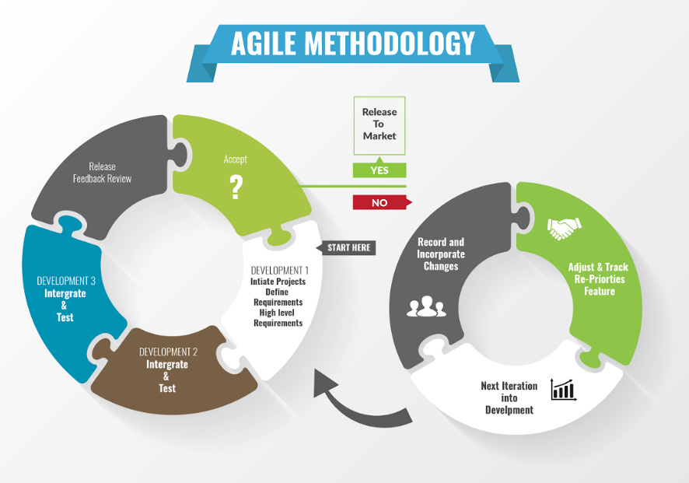

We chose Agile Methodology for its versatile arranging, transformative advancement, early conveyance, and persistent change, and it empowers fast and adaptable reaction to change.

***Usability test***

***Brief description***: Usability testing refers to evaluating a product or service by testing it with representative users.

|  |  |  |  |  |  |
| --- | --- | --- | --- | --- | --- |
| Usability Test | | | | | |
| Item No. | **Test Item** | **Yes** | **No** | **N/A** | **Comments** |
| 1. | **The Website looks appealing.** |  |  |  |  |
| a. | Navigation menu |  |  |  |
| b. | Home Page |  |  |  |
| c. | News Page |  |  |  |
| d. | Account Page |  |  |  |
| e. | Log in Page |  |  |  |
| f. | Register Page |  |  |  |
| g. | Buy Now Page |  |  |  |
| h. | Admin Panel |  |  |  |
| 2. | **The Website is simple to navigate.** |  |  |  |  |
| a. | Navigation menu |  |  |  |
| b. | Account Page |  |  |  |
| c. | Log in Page |  |  |  |
| d. | Home page |  |  |  |
| e. | Register Page |  |  |  |
| f. | Buy now page |  |  |  |
| g. | New page |  |  |  |
| h. | Admin Panel |  |  |  |
| 3. | **Navigation bar is consistent on every page.** |  |  |  |  |
| a. | Home Page |  |  |  |
| b. | News Page |  |  |  |
| c. | Account Page |  |  |  |
| d. | Log-in Page |  |  |  |
| e. | Register Page |  |  |  |
| f. | Buy Now Page |  |  |  |
| g. | Admins Panel |  |  |  |
| 3. | **Text on each page is clear and easy to understand.** |  |  |  |  |
| a. | Home Page |  |  |  |
| b. | News Page |  |  |  |
| c. | Accounts Page |  |  |  |
| d. | Log-in Page |  |  |  |
| e. | Buy Now Page |  |  |  |
| f. | Register Page |  |  |  |
| g. | Admin Panel |  |  |  |
| 4. | **The Website was informative of its purpose.** |  |  |  |  |
| a. | Home page was informative about the developers |  |  |  |
| b. | News Page was informative about upcoming events and news |  |  |  |
| 5. | **Navigation bar links are functional and take me to the correct place.** |  |  |  |  |
| a. | Home Page |  |  |  |  |
| b. | News Page |  |  |  |  |
| c. | Log-In Page |  |  |  |  |
| d. | Register Page |  |  |  |  |
| e. | Account Page |  |  |  |  |
| f. | Buy now page |  |  |  |  |
| 7. | **Forms contain all required fields to fill out.** |  |  |  |  |
| a. | Log in page contains necessary form fields. |  |  |  |
| b. | Register page contains necessary form fields. |  |  |  |
| c. | Buy Now page contains necessary form fields. |  |  |  |
| 8. | **The website displays the expected pages required for its needs.** |  |  |  |  |
| a. | Home page |  |  |  |
| b. | News page |  |  |  |
| c. | Buy now page |  |  |  |
| d. | Register Page |  |  |  |
| e. | Account page |  |  |  |
| 9. | **All forms can be completed and submitted successfully.** |  | X |  |  |
| a | Register form |  |  |  |
| b | Buy Now Form |  |  |  |
| c | Log in form |  |  |  |
| 10. | **Goals of the website look to have be achieved.** |  | X |  |  |
| 11. | **I would revisit this website for further use.** |  |  |  |  |
| 12. | **Shop items priced fairly and labelled clearly.** |  |  |  |  |
| a. | 8-Bit Game |  |  |  |
| 13. | **Clickable buttons are obvious.** |  |  |  |  |
| a | Buy Now button |  |  |  |
| b | Upload image |  |  |  |
| c | Log out button |  |  |  |
| d | Sign up button |  |  |  |
| 14. | **Information gathered from the user is relevant.** |  |  |  |  |
| a | Register form information |  |  |  |
| b | Buy now form information |  |  |  |
| c | Log in form information |  |  |  |

***Database schema***

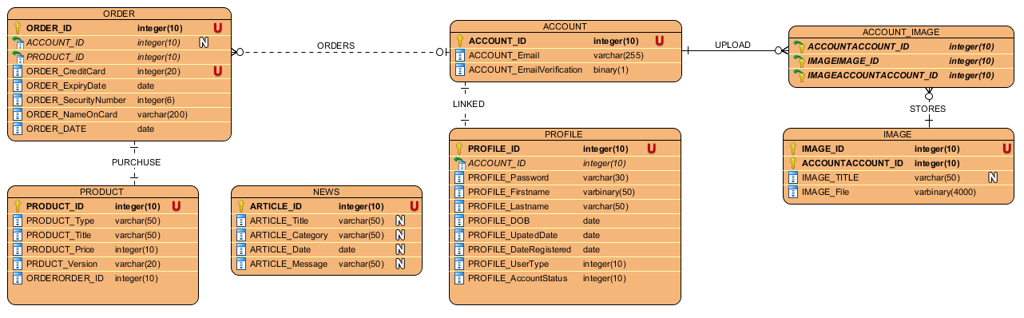

***Usability test result***

|  |  |  |  |  |  |
| --- | --- | --- | --- | --- | --- |
| Usability Test (Completed) | | | | | |
| Item No. | **Test Item** | **Yes** | **No** | **N/A** | **Comments** |
| 1. | **The Website looks appealing.** |  |  |  |  |
| a. | Navigation menu | x |  |  |
| b. | Home Page |  |  |  |
| c. | News Page |  |  |  |
| d. | Account Page |  |  |  |
| e. | Log in Page |  |  |  |
| f. | Register Page |  |  |  |
| g. | Buy Now Page |  |  |  |
| h. | Admin Panel |  |  |  |
| 2. | **The Website is simple to navigate.** |  |  |  |  |
| a. | Navigation menu |  |  |  |
| b. | Account Page |  |  |  |
| c. | Log in Page |  |  |  |
| d. | Home page |  |  |  |
| e. | Register Page |  |  |  |
| f. | Buy now page |  |  |  |
| g. | New page |  |  |  |
| h. | Admin Panel |  |  |  |
| 3. | **Navigation bar is consistent on every page.** |  |  |  |  |
| a. | Home Page |  |  |  |
| b. | News Page |  |  |  |
| c. | Account Page |  |  |  |
| d. | Log-in Page |  |  |  |
| e. | Register Page |  |  |  |
| f. | Buy Now Page |  |  |  |
| g. | Admins Panel |  |  |  |
| 3. | **Text on each page is clear and easy to understand.** | x |  |  |  |
| a. | Home Page |  |  |  |
| b. | News Page |  |  |  |
| c. | Accounts Page |  |  |  |
| d. | Log-in Page |  |  |  |
| e. | Buy Now Page |  |  |  |
| f. | Register Page |  |  |  |
| g. | Admin Panel |  |  |  |
| 4. | **The Website was informative of its purpose.** | X |  |  | Yes but more descriptive details could have been applied. |
| a. | Home page was informative about the developers |  |  |  |
| b. | News Page was informative about upcoming events and news |  |  |  |
| c |  |  |  |  |  |
|  |  |  |  |  |  |
|  |  |  |  |  |  |
| 5. | **Navigation bar links are functional and take me to the correct place.** | X |  |  |  |
| a. | Home Page |  |  |  |  |
| b. | News Page |  |  |  |  |
| c. | Log-In Page |  |  |  |  |
| d. | Register Page |  |  |  |  |
| e. | Account Page |  |  |  |  |
| f. | Buy now page |  |  |  |  |
| 7. | **Forms contain all required fields to fill out.** | X |  |  |  |
| a. | Log in page contains necessary form fields. |  |  |  |
| b. | Register page contains necessary form fields. |  |  |  |
| c. | Buy Now page contains necessary form fields. |  |  |  |
| 8. | **The website displays the expected pages required for its needs.** | X |  |  |  |
| a. | Home page |  |  |  |
| b. | News page |  |  |  |
| c. | Buy now page |  |  |  |
| d. | Register Page |  |  |  |
| e. | Account page |  |  |  |
| 9. | **All forms can be completed and submitted successfully.** |  | X |  | Forms are to be functional in second iteration of the assignment. |
| a | Register form |  |  |  |
| b | Buy Now Form |  |  |  |
| c | Log in form |  |  |  |
| 10. | **Goals of the website look to have be achieved.** |  | X |  | Once functionality is implemented the goals will be achieved |
| 11. | **I would revisit this website for further use.** | X |  |  | If new content was to be created |
| 12. | **Shop items priced fairly and labelled clearly.** | X |  |  |  |
| a. | 8-Bit Game |  |  |  |
| 13. | **Clickable buttons are obvious.** | X |  |  | Clickable links and buttons change colour on hover which is useful. |
| a | Buy Now button |  |  |  |
| b | Upload image |  |  |  |
| c | Log out button |  |  |  |
| d | Sign up button |  |  |  |
| 14. | **Information gathered from the user is relevant.** | X |  |  |  |
| a | Register form information |  |  |  |
| b | Buy now form information |  |  |  |
| c | Log in form information |  |  |  |